**Lesson 13**

**Objectives**

* Cardinality of Relationship
  + One-to-one relationship
  + One-to-many relationship
  + Many-to-many relationship
* Minimum/Maximum Cardinality
  + Optional one
  + Optional Many
  + Mandatory one
  + Mandatory Many

Cardinality of Relationship

Cardinality of relationship means constraints/restrictions on relationship. Cardinality represents the number of instances making relationship with instances of other entity.

Example: one student can take many courses and one course can be taken by many students; here *take* is a relationship and numbers of instances involved in this relationship is called restriction/constraint on this relationship. This restriction is referred as cardinality of relationship. On the base of cardinality relationship is further categorized as; one-to-one, one-to-many, and many-to-many.

**One-to-One**

In this relationship; exactly one instance of one side’s entity is making relationship with exactly one instance of other side’s entity.

Example: HoD heads exactly one department as well as there will be exactly one head for each department. This can be modeled by ER notation as follow

Department

HoD

1 heads 1

This is type of one-to-one relationship due to having exactly one instance of each side’s.

Alternative notation

HoD

Department

heads

In this notation we have not mention cardinality by writing number 1. In this notation it is implicit that when cardinality will be not mentioned then it will be considered 1.

Alternative notation

HoD

Department

heads

In this notation a single vertical bar on each side mention that one instance of each side is involved to made relationship.

**One-to-Many**

A single instance of one side’s entity makes relationship with many instances of the other side’s entity, but a single instance of other side’s entity makes relationship with exactly single instance.

Example: Manager manages many employees but each employee will be managed by exactly one manager. This can be modeled by ER notation as follow

Manager

Employee

1 Manages M

This is type of one-to-many relationship due to having exactly one instance of one side and many (M) instances of other side.

Alternative notation

Manages

Employee

Manager

<

In this notation we have not mention cardinality by writing number 1. But < is used to represent many. Opening side of this symbol will always be on entity side.

Alternative notation

Manager

Manages

Employee

<

**Many-to-Many**

A single instance of one side’s entity makes relationship with many instances of the other side’s entity, as well as a single instance of other side’s entity makes relationship with many instances.

Example: Single student can take many courses as well as a single course can be taken by many students. This can be modeled by ER notation as follow

Student

Course

M takes M

This is type of many-to-many relationship due to having many instances of one side and many (M) instances of other side.

Alternative notation

takes

Course

Student

> <

Some other examples

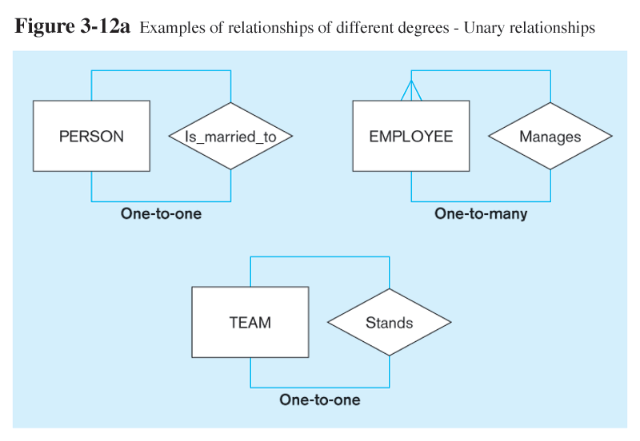

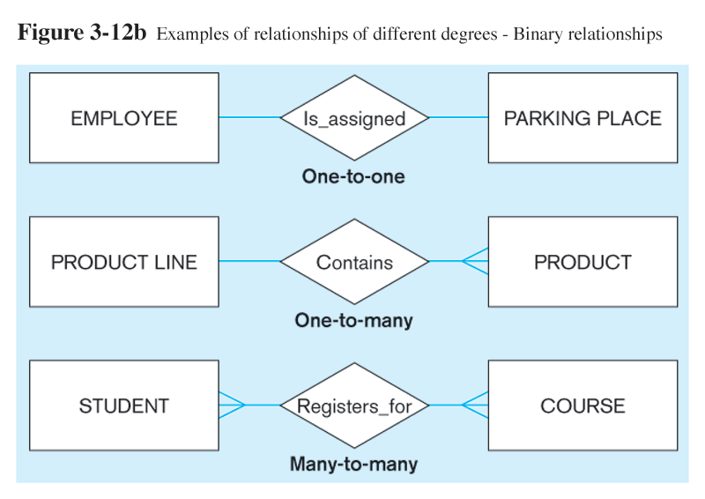

Maximum/Minimum Cardinality:

Maximum/minimum cardinality means; number of minimum and maximum instances of one side’s entity making relationship with one instance of other side’s entity.

Example 1

HoD heads exactly one department;

Here one instance of HoD makes relationship with minimum one as well as maximum one instance of department

as well as there will be exactly one head for each department

Here one instance of department makes relationship with minimum one as well as maximum one instance of HOD.

This can be modeled as

Department

HoD

heads

Minimum

Minimum

Maximum

Maximum

Inner side will represent maximum cardinality and the outer side will represent minimum cardinality of relationship as in above figure. On the base of maximum/minimum; cardinality can be categorized as

* Optional one 0
* Optional many >0
* Mandatory one
* Mandatory many >

Examples was discussed in class

Some other examples are given below

**Optional One Cardinality**

Optional one cardinality means maximum cardinality is one and minimum can be zero. Example

A student can borrow maximum one book from library or may not borrow any book. Here, maximum cardinality is one and minimum is zero. Zero means making a relationship between book and student is optional.

**Optional Many Cardinality**

Optional one cardinality means maximum cardinality is many and minimum can be zero. Example

A faculty member can borrow many books from library or may not borrow any book. Here, maximum cardinality is many and minimum is zero. Zero means making a relationship between book and faculty member is optional.

**Mandatory Many Cardinality**

Mandatory Many cardinality means maximum cardinality is many and minimum is one. Example

A faculty member borrower can borrow at least one book from library. Here, maximum cardinality is many and minimum is one. Minimum one means making a relationship between book and faculty member borrower is mandatory.

**Mandatory one Cardinality**

Mandatory one cardinality means maximum cardinality is one and minimum is also one. Example

A student borrower can borrow exactly one book from library. Here, maximum cardinality is one as well as minimum is one. Minimum one means making a relationship between book and student borrower is mandatory.

Some other examples



Mandatory one

Mandatory one

Optional one

Mandatory Many

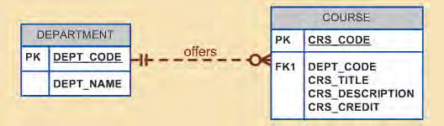

Optional Many

Mandatory one